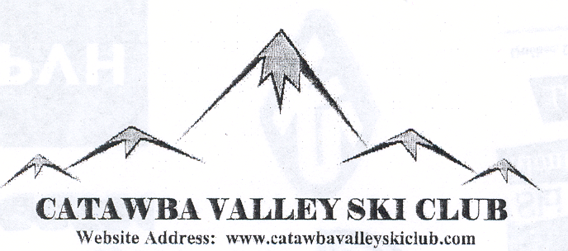
P.O. Box 3286 Hickory, NC 28603

January 14, 2015

December News

Our meeting at the new location, Hickory Airport Terminal, was lightly attended but attendees were unanimous in their praise of the new location as a great meeting place. We had to change the meeting date to the first Tuesday of the month as the meeting room has been booked solid for the second Tuesday of each month.
Discussion was held on how we fared from the movie night back in November. At that time, all of the expenditures were not known and a final figure of the outcome was not known. We were surprised during the meeting by the appearance of Jim Cottrell, president of The French Swiss College at Appalachian Ski Area.

Jim spoke to us about the importance of the upcoming Special Olympics to be held at App during the January/ February time frame. And described some of the poignant experiences that he had observed during his many years sponsoring the event. Several of the members present expressed a desire to help with the program . Most everyone at the meeting donated enough money from their pocket to bring the total from the movie night and the money collected that night to $200.00 for the Special Olympics.

January News

Race results - Our Sugar races went well, great conditions and weather! If you haven’t checked out the new slope (Gunthers Way) it is awesome. George Moser
Movie Night Wrapup–No Report
WebSite - There have been many changes to our webpage, lot of new items have been added and are constantly being added. Go to catawbavalleyskiclub.com and spend some time visiting all of the many pages, photos, links, etc. that are available.
SilverCreek Trip – Pete sent a flyer out looking for members that were interested in attending the Crescent race weekend in March.
Prez Sez = No Report
January Meeting – Lightly attended, discussion held on Special Olympics, club trip to Aspen/ Snowmass, and airplace that crashed one mile after taking off from the airport just a little before our meeting began.
Local Sponsors – Leigh Ford will post a list of our sponsors on the Website.
Race Sponsors - See attachment for those business’ that make Crescent Racing possible. When shopping throw a little money their way.

Ex-President Sez - After listening to the information from Jim Cottrell about the Special Olympics Winter Games, I decided to volunteer and help on the first Sunday of the NC Games. They were held at Appalachian Ski Mountain on Sunday and Monday, January 4th & 5th.

As some of you may remember, the weekend of the 4th & 5th was not the best weekend for skiing. It was overcast and rainy. Fortunately, the rain stopped and the skies cleared just before the Games began. If any of you have skied on rain soaked wet snow, you know that it can be very forgiving. I heard someone call it "Hero Snow." They held the Opening Ceremony and lighting of the Olympic Flame in the early afternoon. The rest of Sunday was practice time for the 120 athletes in the competition. The Hero Snow made for excellent conditions for training. The competition was to take place on Monday. Unfortunately, I had some appointments at work on Monday and couldn't stay for day two.

I spent the afternoon helping Lana, from the French-Swiss Ski College, train the most advanced group of skiers in the competition. She has worked with this group before and had a great relationship with them. I have never seen any group of people have more fun on a pair of skis in my life. Their enthusiasm for the sport and competition is amazing.

I am looking forward to the Southeast Games that will be held on February 1st - 3rd. I have already informed my boss that I will be taking a couple of vacation days, so I can be there to watch these competitors go for the gold!

Some of you should come join the fun!!

Kind Regards,
Tom Rigsby

