Summer 2017 Lake Cookout
At John Link’s Home
Saturday – August 12th – 2:00 pm - Until

4450 3rd St. NW, Hickory
Telephone: 828-781-0147
(Off of Hwy 127 in Moore’s Ferry)
The club and John will provide the essentials for hamburgers and hot dogs with all of the trimmings. Members are requested to bring a side dish, dessert, or appetizer to round out the food stuff. Soft drinks, water, tea, etc. will be provided. Please bring your own brand of alcohol.
Also, you may want to bring a yard chair.
We will need to all pitch in and help on setting things up, grilling the burgers, and keeping the party going.......... so don't be bashful!
Since we only do this once a year, let's make it memorable!!!

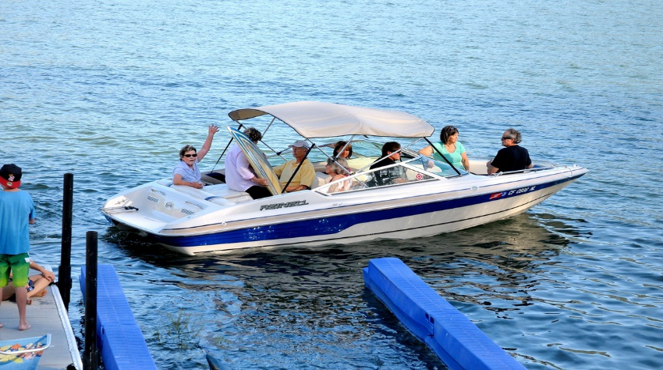
This Photo by Unknown Author is licensed under CC BY-NC-SA

