The Club’s first ski race is at Appalachian Ski Mtn.
Dec. 20th and 21st – 9:45am!

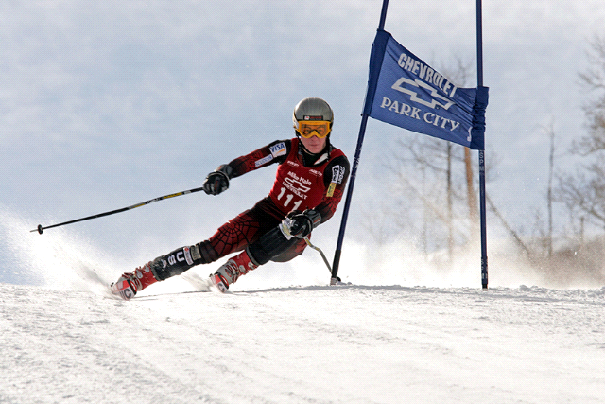

If you are planning on racing you need to let me know no later than 8.00 PM on Mon.
Dec. 15th.

George Moser/ Race Director
828-244-0376 wsvb1@charter.net

